ARGENTINA

Argentina is a territory that defies a single definition. It has the power to amaze or exasperate, but it is never less than fascinating.
From the sub-tropical jungles and steamy falls of Iguazu to the frozen Antarctic waste of Tierra del Fuego, that one territory can contain so much diversity defies belief. This diversity is reflected in the enigmatic but colourful Argentine people.
However, strange as it may seem at first, after a few days it all seems to make sense. Why sleep at night when you can sleep during the day and party all night? It's not all tango either, visit Buenos Aires and you'll find a city capable of rivaling any other in the world for the range and variety of entertainment on offer.
But to come here just to sample city life, no matter how unique a city Buenos Aires is don't miss out on the rest of the country. In its northern reaches and the far-south Argentina has two of the world's greatest natural wonders - the Iguazu falls, larger than Niagara, and the Moreno Glacier, one of the world's few growing ice-fields. In between there is a veritable wealth of history mingled with nature. The colonial towns of early Spanish rule remain relatively untouched, while in the shadow of the Andes, high on the puna, you can find a way of life that pre-dates even these centuries-old invaders.
It all goes towards understanding the country's immeasurable romanticism, where a street kid from Buenos Aires can become the world's greatest footballer, and throw it all away again, and an actress can capture the heart of a nation. Come and fall in love for yourself.

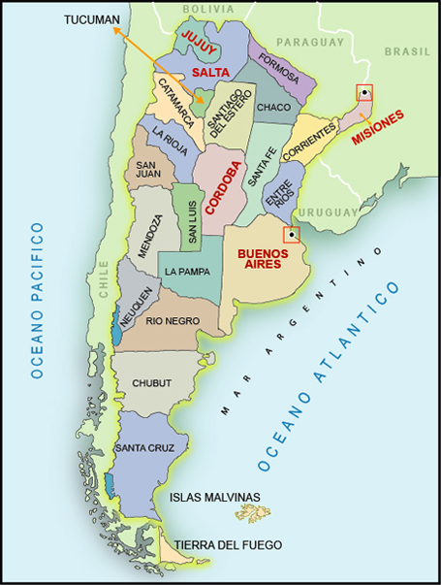

Visa: The visa is to be obtained prior to arrival in the country

Climate & When to Go
Climates range from hot and humid in the north to cold and rainy in the south. In northern Argentina, summer days will be in the 33-37 C and nights in the 23-27 C (winter highs in the 15-22 C and lows in the 5-10 C). Tierra del Fuego, at the southern tip of Argentina, is almost always cold and/or rainy, with summer highs in the 10-21 C and temperatures well below freezing in the winter.
Generally, the best time to go is October-April (remember that the seasons are reversed from the Northern Hemisphere). To lie on the beach, go December-March; to ski, go July-October.

Argentina's vast territory and variations in terrain from coast to mountain means that there is a large variation in climate depending on where you go in the country.
Most people arrive in Buenos Aires and around the capital as well as in the Northeast the climate is more or less sub-tropical. Humid throughout the year the region is characterised by abundant plant growth and high temperatures. The Pampas enjoys a climate more continental in character. Warm summers (Oct-Mar) combined with cold winters are ideal for agriculture and cattle rearing.
The high plateau of the Andes to the west and north is less hospitable. At an average elevation of over 4,000m, vegetation is sparse and, although the climate is hot through summer days the temperature at night consistently drops well below freezing. In winter the region is snow-covered and bitterly cold.
Patagonia further south is similarly a rocky land, characterised by a huge diurnal change in temperature and frequent high winds throughout the year.
Tierra del Fuego at the southern tip of the continent endures a sub-arctic climate. Permafrost in higher areas and glaciers produce a bleak but fascinating landscape. Temperatures are always low, averaging a little higher than 10 degrees centigrade in summer and permanently below freezing in winter.
Peak periods for visitors vary by region, Buenos Aires with its year-round warmth could comfortably be visited at any time, but is probably best seen in the shoulder months, October-November and February-March when the temperatures aren't at their peak. If you're heading for the beaches only the peak months of December-February are really hot enough. In the interior Patagonia and the Andes are at their most hospitable in the December-February period, although even then the temperature can drop below freezing at night.

Transport
Taxis - Taxis are black and yellow. Available ones have a red light on the front, and the fare is metered.
Rail: Service is good to the suburban areas, but it is not recommended for longer distances.
Subway: Five lines connect the city, all of them safe and fast. Service is punctual.
Take note of the nation's public holidays when transport plans can be affected, with more traffic on the roads or a reduced public transport schedule. Although the train network is one of the world's longest with over 40,000km of track, in practice much of this is made up of local and suburban lines and travelling around Argentina long-distance by rail can be difficult.
You should note that the train network has been grossly underfunded in recent years, and although rail transport is cheap the facilities are not always up to scratch. Outside of Buenos Aires you may find it difficult to navigate the railway or plan reliable timetables. It's worth keeping your eye on the national news if using the train (or any other type of public transport in fact) as strikes are not infrequent and seriously disrupt travel schedules.
From Buenos Aires several routes spoke out to major destinations around the country on half-a-dozen mainlines, including to Cordoba (via Rosario), Mar del Plata and Bariloche (via Bahia Blanca). Depending on destination however, it may be quicker to go by coach and you are advised to check this before booking your tickets if speed is a priority. Sleeper cars are available on long distance journeys and should be booked in advance at the ticket office.
The Argenpass is available from train stations and allows unlimited travel on the network for a designated period of 1-3 months.
Tourist trains such as the Train into the Clouds and the Train at the end of the World remain extremely popular. The Old Patagonian Express is a completely steam powered railway through the most spectacular part of the nation and is deservedly counted among the world's great train journeys.
By Bus
Coach travel is one of the best-developed means of transport in the country - mainly because there is a permanent demand from locals for it. From Retiro Bus Station in Buenos Aires you can catch a coach to anywhere in the country. Private companies operate various routes, and prices vary according to facilities on-board and the type of seat you require.
If planning to travel by coach take into account that given the enormous sizes of the country journey times can be very long. For example a trip to Patagonia from the capital can take over 24 hours.
By Car

Although having a car in Argentina has some appeal owing to the sporadic public transport system you have to take a couple of factors into account.
Points to consider:
First of all the distances can be huge, and unless you're travelling with another driver you may find it hard to safely and speedily cover the country.
The following table provides approximate distances between Buenos Aires and major cities and locations throughout Argentina and its closest neighbours. Kilometres in the left of the table, Miles in the middle column. Owing to the vast distances involved in travelling across Argentina by road the third column shows approximate flight time for the same journey. (*no direct flight)
From Buenos Aires | Km | Miles | Time
Mar del Plata | 375 | 235 | 1h10min
Salta | 1300 | 805 | 1h50min
La Rioja | 1000 | 620 | 2h50min*
Iguazu Falls | 1150 | 715 | 1h55min
Cordoba | 675 | 420 | 1h10min
Rawson | 1450 | 895 | 2h
Santa Fe | 400 | 250 | 50min
Bahia Blanca | 640 | 400 | 1h15min
Rio Gallegos | 2550 | 1590 | 2h55min
Ushuaia | 3015 | 1875 | 3h40min
Santiago (Chile) | 1260 | 785 | 2h15min
Montevideo (Uruguay) | 280 | 175 | 45min
• Asuncion (Paraguay) | 1200 | 745 | 1h50min

By Air
International flights arrive at Ezeiza, about 40 minutes by taxi from downtown Buenos Aires. Domestic arrivals land at Aeroparque Jorge Newbery, 10 minutes from downtown by taxi,
Major carriers include: Aeroflot, Avinaca, Aerolineas Argentinas, Air France, American Airlines, Alitalia, Aeroperu, Austral, British Airways, Canadian Airlines, Dinar, Iberia, KLM, Lan Chile, LAPA, Lloyd Aero Boliviano, Lufthansa, Malaysia Airlines, Pluna, South African Airways, Swissair, TAM, United, Varig, Vasp.
From Buenos Aires domestic flights and flights to Uruguay leave from the Jorge Newbery airport, which is to the north of the city. Flights connect to places such as Salta, Ushuaia, San Salvador de Jujuy and Cordoba among others.
Prices are very reasonable considering the time you save and the distance traveled. Aerolineas is the national operator and although the economic downturn has hit the airline hard it is still operating internal flights all over the country. Tel: 0810-222-86527 from Argentina for flight information and booking.
There is a departure tax payable at the airport of USD30.50 for international flights and USD2.50 for domestic flights (except Calafete, where passengers must pay USD7 and Ushuaia, where they pay USD5).
At the moment, shopping in Argentina is much cheaper than a few months ago due to the devaluation of the local currency. While dollars are generally accepted, foreign currency can be exchanged in banks and authorised bureaux if need be.

Culture
Everyone will tell you that Argentine culture is the sum of a massive and varied influx of Europeans, but if that's so it's certainly become much more than the sum of its parts.
In its staunch Catholicism and outlook on life it is distinctly European, and few places seem to value Siesta as much as Argentina.
The other over-riding passion of the nation is football, almost displacing religion in people's priorities on occasion. Perhaps the greatest exponent of this particular sport sums up the country better than any other. A kid from the streets of Buenos Aires, Maradona was the finest player of football that ever graced the world stage, through the 1980s he turned soccer into an art form, and is revered more highly than anyone in Argentina today. Yet Maradona, as well as being the finest player in the world was also the most vicious perpetrator of the worst side of the game. He persistently cheated, complained and fouled, and in the final stages of his career was found to be using drugs. But this matters not to the Argentine people. They value beauty above all else and can forgive any number of flaws if the person committing them has charisma and charm - forgiving Maradona's transgressions as merely a precocious cheek that comes with prodigious talent.
The culture is also extremely machismo, with the epitome being the swaggering Gaucho cowboy, with his knife tucked into his broad belt. What would be considered offensive in many countries is seen as merely boyishness here, although at the same time something of a matriarchal society persists with the eldest female often being the most deferred to person in family groups.

Dos and Don'ts
Feel comfortable smoking in almost any public place. In some bars there is a division between smokers and non-smokers, but these norms are not socially nor legally respected.
Chat to your hosts. They adore speaking with foreigners about soccer, family and just about anything else. They also love to hear foreign accents speaking Spanish, a source of seemingly endless amusement.
Do not take regular taxis in the street. Call to ask for a "radio taxi" or to a "remise". There are plenty of these companies in Buenos Aires. In the provinces, you can trust a little bit more in common cabs.
Do not ask for help or for directions to anyone in the street. You can be "betrayed" by your accent in Spanish or just by speaking English and thieves can identify you as a possible victim.
Don't be over-formal when greeting. People generally kiss one cheek (even between men) or they shake hands if there is a business relation between both persons or if there is a big age difference between them. Women are almost always kissed on one cheek.

Shopping:
The favourable exchange rate means that it is worth browsing the stores of Argentina's main cities for international branded goods. Wander down Buenos Aires's Calle Florida and Ave Santa Fe for the most upmarket stores in the country. Although the selection is unlikely to be anything different from back home the prices can be significantly less and you can obtain real bargains. The Sunday Flea Market in San Telmo provides excellent, leisurely people-watching and shopping, and there is a very good Sunday Antiques Fair at the Plaza Dorego.
The best things to buy remain the traditional crafts that Argentines have made for centuries. Throughout the country you'll find fabulous leather work from bags, belts and accessories all the way to full coats. Of course besides this traditional merchandise you could always purchase an icon of modern life in an Argentine football shirt. The distinctive pale blue and white stripes are the most famous colours in football, besides the yellow of Brazil. The most famous number is "10" - Maradona's.

Opening Hours: Stores in the large cities will open from 09h00 to 20h00 every weekday. In more rural areas and smaller towns shops may close for an extended time from 12h00, and re-open later for the evening trade. Most shops will close at around 13h00 on Saturdays. Sunday opening is not practised.

Tax Refund:
A VAT of 21% is added on to the price of most goods and services in Argentina. Tax can be reclaimed on any purchases over USD70 in value. The amount must be covered on a single invoice from a store that participates in the Global Refund scheme. You have to prevent the appropriate receipt (which displays the amount of tax paid) and the goods at a global refund desk at the point of international departure. The refund can then be processed and sent to you, or re-credited into your bank account.

Food
Argentineans love to eat and to cook. You can find a range of European, Asian, and Indian restaurants throughout the country, besides the more expected offerings from South and Central American cuisines, including Brazilian, Chilean, Mexican, Caribbean and Peruvian.
Specialities
Locro: A stew made of meat, potatoes, corn and sundry other vegetables. It is generally a winter dish.
Empanadas: filled with ham and cheese, corn, spinach, onion and cheese, prunes and ham, pineapple and ham, chicken, tuna fish or indeed just about anything you can stuff in them.
Asado: The traditional Argentine barbecue
Milanesas: Thin veal, beef or chicken steak cuts, covered with seasoned breadcrumbs and fried fillings.
Dulce de Leche: It is like a jelly but made out of cooked sweetened milk - and it is very, very sweet. Argentineans use it as a topping on cakes, pancakes, pieces of toast, cookies... literally everything.
Chocolates: Chocolate is extremely popular and is of as high quality as you can find anywhere in the world. In Bariloche city, Argentina's chocolate capital, you can choose between 130 varieties of chocolate and you can even have chocolate fondues.
Drinks
The Argentineans predominantly drink local wine with main meals. You can choose between "tinto" (red), "blanco" (white) or "rosado" (rosé). The most popular brand is Quilmes although there are others throughout the country - such as the Cordoba label.
Currency: Argentinian Peso (ARS). ARS1 = 100 centavos
Notes: ARS100, 50, 20, 10, 5 and 2
Coins: ARS5, 2, 1 and 50, 25, 10, 5 and 1 centavos
Credit cards: Credit cards are widely accepted in large hotels and restaurants. The most popular international cards such as American Express and Visa will often be accepted in stores and smaller shops as well. If an "old-style" credit slip with a carbon copy of your card is taken ensure that you cross through the empty boxes in the "Total" section. It has been known for additional figures to be added after the slip has been signed.

Exchange The US Dollar is generally accepted as legal tender, and you should carry this currency while in Argentina. Other foreign currencies can only be exchanged in licensed banks and cambios. It is heavily advised that you only exchange currency as and when you need it as the Peso is extremely devalued and rates change on a daily basis.
Banks are open Mon-Fri 1000-1500. You should be aware that Argentina went through an economic crisis between 1999-2002. Large amounts of money was withdrawn from the country caused by the loss of confidence from investors.

Tax Refund
A VAT of 21% is added on to the price of most goods and services in Argentina. Tax can be reclaimed on any purchases over USD70 in value. The amount must be covered on a single invoice from a store that participates in the Global Refund scheme. You have to present the appropriate receipt (which displays the amount of tax paid) and the goods at a Global Refund desk at the point of international departure. The refund can then be processed and sent to you, or re-credited into your bank account.

Service Charges Tips are not necessary but in practice they are often offered and never refused. Some hotels or restaurants will add 25 per cent service charge to the bill and waiters may still expect a tip - it is to your discretion whether you offer one. Otherwise, ten per cent on top of the bill will suffice. The same applies in bars. Taxi drivers tend to expect tips from visitors.

Telephone

International dialing code: 54
Area codes: Buenos Aires: 11, Cordoba: 351, Salta: 387, Mar del Plata: 223, Mendoza: 261 Area dialing codes are preceded by 0 when dialing within the country.
Public telephones are both card and coin operated.
Health Concerns
Tap water in cities and certainly in large hotels is safe to drink. Outside of main population centers you should be more wary of drinking from the tap and use bottled water instead. Never drink from a watercourse, A common complaint is stomach upsets, and to minimise risk of contracting even this minor illness you should take care to avoid eating unpeeled fruit or uncooked vegetables for at least a few days after arrival.
Although medical facilities in Buenos Aires and other cities are excellent they are also very expensive. Medical insurance is essential, and make sure it covers you for activities such as rafting, climbing and hiking if planning on undertaking such pastimes during your stay.
Vaccinations: None needed.
Personal Safety Argentina is not as dangerous as many people think. Buenos Aires has a reputation for violent crime, but any that occurs is mainly confined to the suburbs and in the small towns of the province rather than in the city centre. Nevertheless take care not to carry too many valuables visibly while walking around the city. If driving, keep your car door locked at all times. Car hijacking has been known to occur.
In the current political climate demonstrations, protests and even riots have been occurring sporadically for some time. Avoid large gatherings of people if you see them. Often the authorities make arrests of anyone they think may be part of the demonstration. As with everywhere try not to carry anything valuable or that you cannot afford to lose. With poverty rife in Argentina foreigners are often perceived as wealthy, sometimes it's better to deliberately give the impression you're not. If a victim of armed theft you are advised to comply with your assailant rather than resist.
You should take great care if traveling in the mountain and plateau regions. Even in summer the night temperature can drop well below freezing at altitude, and you should ensure that you are equipped for such extremes of temperature.
The main hospitals in Buenos Aires are the German Hospital, Fernandez Hospital, Clinica Suizo Argentina, Clinica Bazterrica, Rivadavia Hospital, French Hospital, Clinica de la Trinidad, and Italian Hospital. For emergencies, Asistencia Medica SAME.

Emregency Numbers:
Police:100
Ambulance:101
Fire:100
BUENOS AIRES
The Argentine capital is at once a traditional and avant-garde city. A sprawling place of nine million inhabitants, Buenos Aires is most easily defined by its neighborhoods: Buenos Aires is also well known for its great soccer stadiums, tango music and dance (that can be best listened to and viewed in the traditional Café Tortoni). The wide selection of cultural institutions such as the recently opened Latin-American Museum of Art (MALBA) shouldn't be ignored: this is very much Argentina's cultural capital as well as being the seat of government. There is also a wealth of beauty and history here, and no tourist can leave the city without visiting Palermo Park and the Plaza de Mayo, surrounded by such symbolic buildings as the Cabildo (town hall), the cathedral, and the Casa Rosada, the government's headquarters
Attractons
San Telmo where the visitor can buy antiques in a market surrounded by colonial style buildings. Then there's elegant Puerto Madero and La Boca where the first Genoese immigrants settled in red, blue and yellow houses along picturesque Caminito Street.
Teatro Colon
The Teatro Colon needs little introduction to those familiar with the opera. As one of the world's premier opera houses, it has hosted the likes of Maria Callas, Toscanini, Stravinsky, and Caruso. Tickets are hard to come by, as many of the theater's 3,500 seats are held by season ticketholders. A guided tour lets the visitor glimpse the inner workings of this eminent center of opera
Plaza de Mayo
The Plaza de Mayo is the city center (the city, in fact, was literally built around it), some of Argentina's most important historical events took place here. Surrounding it is the Government House, the Metropolitan Cathedral, and the Cabildo (town hall). Today the Plaza probably owes most of its fame to the Madres de la Plaza de Mayo, the women who still show up in the square seeking information on the deseparecidos, their loved ones who vanished during the DirtyWar.
The Recoleta
This area is the most fashionable place in Buenos Aires to dine; it is adjacent to the Cementario de la Recoleta, Eva Peron's final resting place. Along with Evita's much-visited grave, there is Our Lady of the Pilar Church, the Cultural Center, and the Palais de Glace, a major gallery. You can walk along the Pilar, which brims with a wide variety of restaurants and venues featuring live music every night.
San Telmo
San Telmo is widely hailed as the most picturesque part of Buenos Aires. Cobblestone streets and colonial buildings set the atmosphere for an array of shops and boutiques, tango parlors and cafes.

La Boca
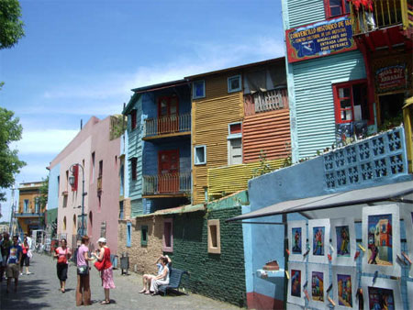
Perhaps the most colorful area in Buenos Aires is La Boca (the Mouth), which sits along the port. Here an assortment of brightly painted low houses made of wood and metal burst upon the eyes in a scene that could almost be from some- where in Scandinavia. The main street here is Caminito, which has an artisans and painters fair, open air tango shows, and typical Italian cantinas. Tip: For security reasons, avoid La Boca at night, and do not stray from the tourist areas.

The Parque Lezama
This is one of the city's most attractive parks--enormous magnolias, palms, and cedar elms grace the winding paths among the hills, and a smoothly-flowing river cuts through the park center. At the Museo Historico Nacional, Argentina's turbulent history is reviewed, from the 16th century to the present. It features a collection of paintings by Candido Lopez, a primitive stylist and one of Argentina's most important artists. The Catedral Russo Ortodoxo, with its soaring and majestic onion domes, is one of the city's many fine architectural ornaments. Curiously enough, it is still owned by Russia.
Palermo
Palermo is area of woods and lakes, on large park composed of many small ones. Among the attractions are a pleasant rose garden filled with sculptures, polo fields, and the Japanese Garden.
Tigre
Situated on the Parana River Delta, Tigre is a natural playground consisting of 350 rivers and streams and an ecological reserve. You can partake in water sports and fishing, or check out crafts at the Fruit Dock. There are also two museums here, the Navy Museum and the Sarmiento.
Estancias
A great excursion from the city is a visit to one of the many Estancias, or Argentine ranches. Here you can get a sense of the traditional life of the gauchos. Many Estancias offer accommodations, traditional food, live folk music and dancing, and exhibitions of gaucho horseback skills.

CORDOBA
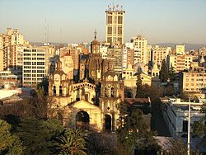
Argentina's second city, Cordoba is less frenetic than the capital to the south-east. At the heart of the wide northern part of the country, in colonial times the city rivalled Buenos Aires as the administrative and government centre. In the 17th century Cordoba was arguably the more important of the two, and the architecture that survives from this period indicates the wealth and influence the city possessed. The colonial buildings of the historical quarter are the grandest found anywhere in Argentina, and have been preserved even as Cordoba's political importance has declined. Highlights include the cathedral (built in 1574),

Cabildo

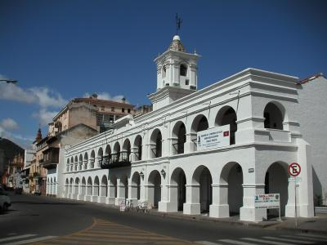
The Cabildo (the town hall dating from1588) and Argentina's oldest university.
The first site is the Town Hall, built by the marquis Sobremonte.We recommend visiting the subterranean cells and the so-called"Salon Rojo" (Red Room). Often there are concerts in the "Patio Mayor" (Main Courtyard) and art exhibitions.
A few steps ahead stands the Cathedral, which was initiated in 1574 and wasn´t finished until two centuries after. The result was a mixture of styles, unified by the monumentality of the work.
Opposite these two buildings is the plaza "San Martin", built in 1577. The plazas lovely gardens date back to the second half of the 19th century. The central monument, dedicated to the general San Martin, was inaugurated in 1916. Next place to see is "Museo de Arte Religioso Juan de Tejeda" (Museum of Religious Art Juan de Tejeda), the only one of its kind in Argentina. The museum exhibits the valuable collections of religious art that belonged to the cathedral long ago.
Nearby there is the pedestrian zone Obispo Trejo, where you can admire interesting 19th century constructions. You must make a stop at the "Universidad Nacional de Cordoba", which is the first university the country has seen, and its Main Library with priceless incunabular books.
Next to the university you will find the Compañia de Jesus Church, with a certain aspect of a medieval fortress, consecrated in 1671 and considered the oldest in Argentina.
The San Martin Theater, the oldest in the country, was inaugurated in 1891 and has an excellent acoustic.

Marquis of Sobremonte Provincial History Museum (Museo Histórico Provincial Marqués de Sobremonte) Besides this rich history Cordoba also possesses several cultural institutions that count among the country's best. Its 26 rooms contain a collection of artefacts from colonial and post-colonial days in the region. The city is also a centre for the performing arts - the San Martin Theatre is Argentina's oldest, inaugurated in 1891. It still plays host to drama, dance and orchestral performances.

Atlantic Coast Although it's rarely the first place that people think of for a beach holiday Argentina's thousands of kilometers of coast contains several world class beach resorts.
The city of Mar del Plata, in the province of Buenos Aires, is the most popular beach resort in Argentina. Located south of the capital it is just one in a series of resorts that cover a vast swathe of the coast. The town itself is pleasant enough and the landscape varies between beautiful beaches and fabulous coastal scenery such as the Barranca de los Lobos sea cliffs. The 19th-century lighthouse at Punta Mogotes is something of an icon, visible from miles away along the coast.
Other resorts to consider include Mar de Ajo, Miramar, San Bernardo, Santa Clara del Mar, and Santa Teresita. The summer months of November-February are best for visiting Resorts
And also nightlife in Córdoba has many cultural and entertainment alternatives. It's a city to be fully enjoyed.

THE PAMPAS

The Pampas West of Buenos Aires the plains of the Pampas cover a vast swathe of Cordoba, Santa Fe and Buenos Aires provinces. It is a magical expanse of incomprehensibly wide open spaces and an unbroken horizon. This is also the land of the gauchos, the legendary Argentinean cowboys that epitomise the machismo culture of the country. La Pampas, in the centre of Argentina, is the largest and best-known area. A land of lush plains it is the country's centre in terms of population, industry and agriculture. Towards the south, there is the sterile and stony plateau of Patagonia, swept by the wind during most of the year. The tiny piece of Tierra del Fuego that belongs to Argentina is on the east side of the continental tip. It contains the world's most southerly city Ushuaia.
The territory contains several attractions of note. One of the best ways to experience the Pampas is to stay at one of the colonial style ranches, which still farm cattle in the traditional gaucho way. Tourists are invited to sample the life of a Pampas cowboy, with gaucho style barbecues and traditional activities of horse riding, hunting and fishing.
Mar del Plata
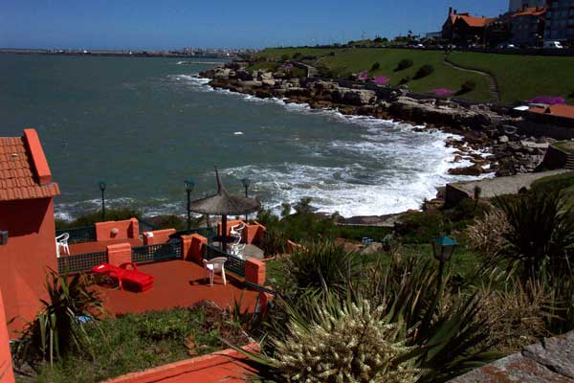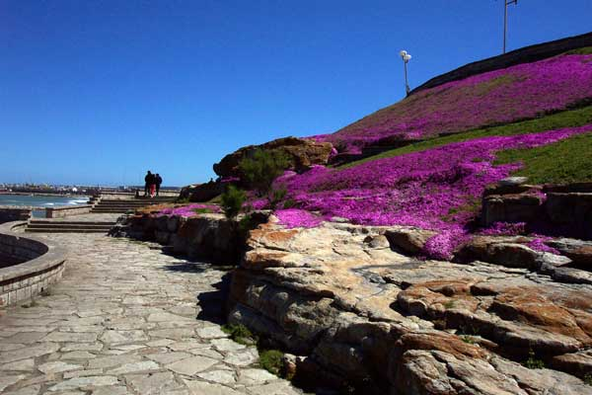

The classic beach resort town in Argentina, Mar del Plata has everything. It gets very busy and crowded in the summer months. If you prefer quieter deserted dune beaches, look around the area for a larger variety of beach options like Pinamar.

San Antonio de Areco
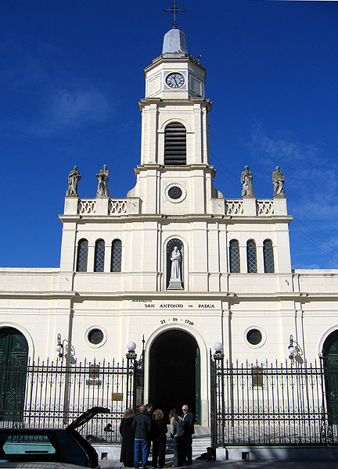
The heart of traditional Argentinean and gaucho culture, this town greatly values Argentina’s history and explains it to the visitor, and has many estancias for tourists to stay in. November 10th is the “Dia de la Tradicion,” a holiday celebrating traditions, and is both a lot of fun and educational. If you prefer to be in a more rural setting, look into the variety of estancias to see las pampas firsthand.

Elsewhere in the Pampas you can visit the salt lakes with their populations of bright pink flamingos or head for the National Park of Liahué Calel where other indigenous wildlife can be seen - including pumas, the large wild cat of the plains. A magnificent national park, unfortunately somewhat difficult to access without a car, it is interesting both in terms of its wildlife and ecosystems, and in terms of its archeological sites.

Other places of interest include the pilgrimage city of Lújan and its magnificent basilica that houses the tiny statue of the Madonna; site of many recorded miracles over the centuries. Further north you should also visit Rosario with its pristine colonial architecture.

Go Gaucho:
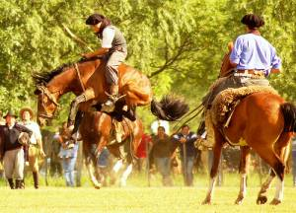
Staying at an estancia, horseback rides are also obviously available, and some estancias even offer multiple day excursions, camping in the pampa and living the way gauchos did in the past.

Iguazu Falls:
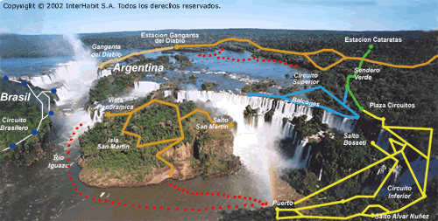

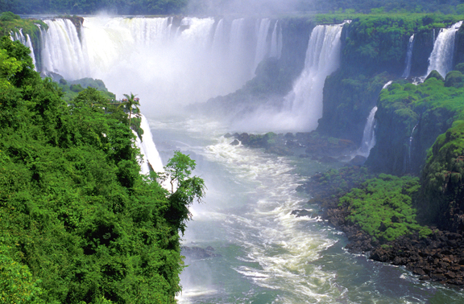

The Iguazu Falls are inarguably one of the world's natural wonders. Surrounded by dense jungle vegetation and incredibly varied fauna and flora, the Iguazu River divides into 275 separate channels, which plunge over the lip of a horseshoe over three kilometres in length. At their highest point the water plummets over 70 metres into the basin below. With literally thousands of gallons crashing down each second the noise is deafening and can be heard a long time before you actually see the falls for yourself. As the water reaches the bottom the spray rises and the sunlight forms numerous rainbows.
In the midst of verdure foliage, Iguazu Falls Argentina is located 17 km to the southeast of Puerto Iguazu. Argentina Iguazu Falls is an ideal place to explore nature and its pristine glory. With around 275 cascades making up the one majestic waterfall, the major highlight of Iguazu Falls is the crescent-shaped Devil's Throat. Argentina Iguazu Falls is located within the Iguazu National Park.
In Guarana language, the Iguazu Falls means 'big water'. Falling on the border of Argentina and Brazil, the falls beckon adventure enthusiasts to witness the churning white noise with the breathtaking backdrop. An ideal time to visit the Iguazu Falls in Argentina is in between August and November. The falls form the border of three countries, Argentina, Brazil and Paraguay and are encompassed by the Iguazu National Park. The surroundings are almost as much of a tourist draw as the falls themselves and you can bathe in the warm water of the river and enjoy spotting the myriad fish, insect and mammal life that has made its home in this unique eco-system. Many of the inhabitants are threatened species and you'll be very fortunate to catch a glimpse of some of the rarer large animals such as the giant otter or the jaguar.

• The Iguazu Falls in Argentina have an access with a Visitor Center where tickets are sold.. The ticket includes two train and a boat ride that crosses over to the San Martin Island. To get to the main gate, there is a bus service running every 45 minutes from different points of Puerto Iguazu: downtown, Hito Tres Fronteras (main area of Puerto Iguazu hotels), the Bus Station and Ruta 12. The bus is about approx USD 2 per person each way.
• Once inside the Iguazu Falls Park you can hire bilingual guides or make the tour on your own. The are closest to the Visitor Center comprises a patio with restaurants, souvenir shops, an amphitheatre and a space dedicated to the Park´s ecosystem. There is also an exhibition of natives who lived in the area during the past centuries. The exhibits are in Spanish only.
• The train terminal is at Central Station, some 400 mts away from the main gate. Here is where the first leg starts and you can either ride the train or take a 20-minute easy walk along Sendero Verde (green trail). Both ways will get you to Cataratas Station, the starting point of the Upper Circuit
• The Upper Circuit is a half-hour walk along a 1200 mts trail – with low degree of difficulty and no stairs – that goes deep into the jungle. All of a sudden, you run into breathtaking views of the Falls. You will get lots of closer views at the different observation points, and more panoramic sights toward the end of the trail (see Iguazu Falls pictures)
• The Lower Circuit requires more physical effort due to its stairs but it can be perfectly done if you take it nice and slow, catching your breath on the different viewpoints. On this trail you will also walk deep into the jungle, crossing streams and coming across local fauna.
• The Lower Circuit goes all the way down to the river, where the boat crosses over to San Martin Island. On the way down, there are balconies with marvelous bottom-up views of the falls (the same falls that you see from above in the Upper Circuit). If you have any physical impairment, stay away from this last section.
• If you want to enhance your Iguazu Falls experience, try the Great Adventure which takes you by boat right to the base of the Garganta del Diablo (Devil’s throat fall), right below the 70 mts waterfall (see Iguazu Falls tours)
• The second leg of the train ride leaves from Cataratas Station and goes to Garganta del Diablo Station, a small area with fast foods and toilets. The trail goes across several branches of the upper Iguazu River, deep into the rain forest. Visitors get to watch various kinds of birds – such as beautiful toucans.
• Garganta del Diablo (Devil’s throat) is a 70-meter-deep pot where several branches of the Iguazu river converge causing a violent water fall. A balcony set up at the border allows tourists to enjoy a once-in-a-lifetime experience.

Touring Iguazu Falls, Argentina
You can walk the trails in any order, and most people start at Garganta del Diablo. But if you are in for the day, it´s better to do the upper and lower circuits during the morning when the heat is reasonable. Take a break at lunch time and then walk the trail to Garganta del Diablo. This is also the part of the day with the best light for your pictures.
Do not miss the guided tour to Garganta del Diablo on full moon nights. It is absolutely amazing!
The Jesuit Missions
Up in the Northeast, south of the Iguazu Falls in the Misione region, is one of the most intriguing locations in South America. This area (including parts of Paraguay and Brazil) was the site of the most advanced civilisation of the 17th century - the Jesuit Missions. These were a series of 30 towns (reducciones) established between approximately 1600-1680 by a band of Jesuit missionaries. Granted the right to do so by the King of Spain, they set about converting the native Guarani people of the region to their own brand of the Christian faith.
Although founded in religion the society that developed was the most advanced and enlightened of its time. The missionaries protected the Guarani from the European slave traders, teaching them literacy and practising an early form of communism, which actually worked. The Jesuits also fostered the Guaranis' natural skills, and established an economy based on traditional crafts.
All the reducciones were built on roughly the same model, with a church, hospital, public buildings and houses surrounding a central square. The remains of the towns, which can be visited today, show just how sophisticated these settlements were. Many were towns of up to 20,000 inhabitants - today the native Guarani number only double that. Designated UNESCO heritage sites, the ruins at San Ignacio Mini and Santa Ana are the best places to witness this unique slice of history.

Salta and "The Train to the Clouds"
Although it falls within the Andean Plateau region (see below) Salta deserves a mention in itself. One of the best-preserved colonial towns in the whole of Argentina, it is of great historical interest. The Spanish-inspired architecture is shown off to best effect in the central square, which contains the cathedral and town hall.
The latter building contains several museums of interest to anyone keen to learn more about the history of this isolated but beautiful city. The Museum of Northern History and the Colonial Museum are pretty self-explanatory, telling the tale of both the people that used to live here and those that usurped them.
Salta is most famous for the train that leaves the town and climbs up to the high puna above. Not for nothing is the train called "El Tren a las Nubes" (literally "The Train to the Clouds"). One of the world's most spectacular train journeys the route crosses the La Polvorilla viaduct, over 4,000m above sea-level and itself over 60m in height. The town of San Antonio de los Cobres is the last stop before the viaduct and offers a real taste of life on the plateau.
NW Andean Plateau
The historical heart of Argentina, the north-western sub-Andean region is a fascinating area well off the beaten track. It is a region of great natural beauty and the Jujuy province contains Calilegua National Park where you can see the indigenous flora and fauna of the high plateau. Capital of Jujuy, San Salvador de Jujuy is an intriguing town with several museums that trace its history through colonial times. North of the city you'll find the remains of tribal villages that existed long before the conquistadors ever set eyes on the continent.
In Estero, the capital Santiago del Estero is Argentina's oldest city. Estero is also a famous spa region and many people come to bathe in the thermal springs of towns such as Rio Hondo. Head for the La Rioja region for viticulture and the natural attraction of the Talampaya Canyon. Throughout the rest of the region you'll find plenty else of interest, from the activities and attractions afforded by the mountains to ruins of colonial forts.

Mendoza and the West
The Mendoza province and its eponymous capital is Argentina's wine growing region. In the shadow of the Andes, and South America's highest peak - Aconcagua - the manmade irrigation channels have turned the arid central plain into an agricultural oasis.
The city of Mendoza itself sits at the centre of a spider's web of irrigation. It is a lively city and nearly 500 years old, but is characterised by the wineries that surround it rather than anything intrinsically beautiful in itself. These vineyards are the central figures in the Argentinian wine industry and many of them offer tours and tastings.
Head for the lower slopes of the Andes in winter for the region's other main draw - skiing. Ski centres such as Las Leñas and Los Penitentes attract winter sports enthusiasts from all over the world to their pistes.

Patagonia

There are few places on earth that can match Patagonia for natural beauty. The landscape is simply breathtaking, with prehistoric forests, deep blue-green lakes and massive glaciers.
The best of the region is undoubtedly the UNESCO World Heritage-listed Los Glaciares National Park in Santa Cruz province with its Moreno Glacier centrepiece, a constantly moving behemoth of ice. It is one of the few places where you can see icebergs calving, as the glacier spills into Lake Argentino. This southern tip of the Andes spine is an incredibly bleak place, with severe granite mountains and sparse vegetation. It is an incredible wilderness that can't help but fascinate.
Bariloche is the capital of the Andean part of Patagonia. A popular destination in winter when the surrounding mountains offer some of the continent's best skiing, it is likewise popular in summer with climbers and trekkers who come to try their skills on the imposing peaks. The coast of Patagonia is as fascinating as the interior - the Valdes Peninsula juts out into the South Atlantic and in its shelter you can see southern right whales during the breeding season of May-December. Further south at Punta Tombo is the world's largest colony of Magellan penguins.

Tierra del Fuego
If there are few places on earth like Patagonia, there is nowhere on earth like Tierra del Fuego. This very tip of the continent is shared between Argentina and Chile and it is hard to imagine a more inhospitable territory. The "land of fire" lies on a geological fault and the entire peninsula is characterised by volcanic activity. The geography bears evidence of the violence of the earthquakes that have shaken the land here; it has literally shattered into fragments.
On the Argentinean side of the region you'll find the most southerly city on earth, Ushuaia. The city is the embarkation point for Antarctic surveys and, as such, it is very much a working town. But there are still some sights of interest here, most notably the Museum at the End of the World, which bears testament to the fact that people have been eking a living out here for centuries.
The Tierra del Fuego National Park is an amazing region of jagged coastline, massive spiked peaks and glaciers. The best way to get here is to catch the "Train at the End of the World", a steam train that runs from a station just to the west of Ushuaia into the park

Indian Restaurants:

Tandoor

Laprida 1293 (at Charcas)
Barrio Norte, Buenos Aires
Phone/Reservations: (+54 11) 4821-3676

Open Monday thru Saturday from 8 pm
We accept reservations for seating till 9 pm (after which seating is by order of arrival)

Katmandu
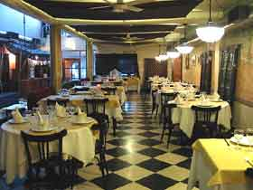
Address: Av Cordoba 3547, Palermo
Buenos Aires
Zip code: 1188
Argentina
Open Monday to Saturday 19:30 hrs and onwards Monday to Saturday for dinner only, prior reservations are recommended.

Mumbai
Address Paraguay 436, Location :Downtown
Tel: 4315 0075 * 4961 2670
Lunch 12:00 to 15:00
Dinner 19:00 to 23:00

